In-class Exercise 1

- Create an Alice world with the grass template

- Add a bunny (Animals gallery folder) to the world

- Using the layout tools in the upper-right corner of the Alice interface, position the bunny so that it looks like the picture below

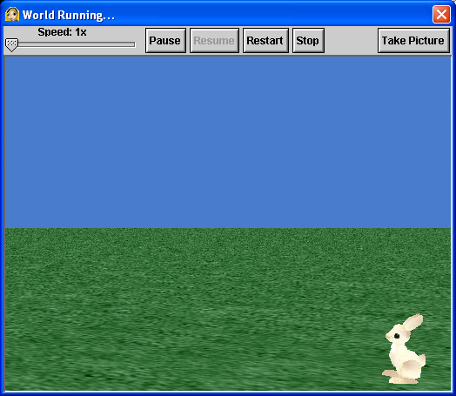

- Click the World tile in the Object tree in the upper-left corner of the interface

- Click the methods tab in the Details area. You will se that the name of the method in the Details area is simply my first method, but in the Editor you see the full name of world.my first method.

- Click the bunny tile in the Object tree. Now you can see information about the bunny in the Details area. You should be able to see the bunny’s methods. You create new code for Alice objects by dragging tiles for objects, other methods, and control structures into the method you are currently editing. You get object tiles from the Object tree, method tiles from the methods tab in the Details area, and logic and control tiles from the bottom of the Editor area.

- Make sure that the methods tab is selected in the Details area, and then find and drag the bunny move tile into the middle of world.my first method in the Editor area. A short menu will appear asking you to choose the direction and amount you want the bunny to move. Select forward for the direction, and then 1 meter for the amount.

Note: information that you must give to a method whenever you use the method is called a method parameter. Direction and amount are two parameters for the move method.
- To test your world, click the Play button near the upper-left corner of the Alice interface. You will see the bunny move. It’s not much, but it’s a start. Click the Restart button to play the world again, and then click the Stop button to return to the standard Alice interface.

- To change the amount the bunny moves, click the 1 meter parameter in the move tile in your new method, and then choose one of the values in the drop-down menu that appears. You can also click other and then enter a number on the calculator-style keypad that appears. Try changing the amount a few times and then playing the world after each change until you can make the bunny move approximately to the middle of the screen.

- Let’s add a few more instructions. First, find the bunny turn to face method tile. It’s in the Details area about 11 or 12 tiles below the bunny move tile that you just used. You will probably need to scroll down to see it. The parameter for this tile will be the object you want the bunny to face. Click and drag the bunny turn to face tile into the Editor area below the bunny move tile, and choose camera as the object you want the bunny to face.

- Next you are going to add two tiles to make the bunny speak, and then save the method. First, find and drag the bunny say tile into the Editor area below your other two instructions. The parameter for this method is the phrase you want the bunny to say. This parameter is a string parameter, which contains a string of characters from the keyboard. When the parameter menu appears, click other, and then type Hello, World! In the Enter a string input box that appears, and then click OK.

- Now play your world again. When you are convinced it works, you are done.

- Save the world you created. Click the File menu and then click Save World. Notice that Alice has File menu options to Save World and to Save World As. The first time you try to save a new world, you will see the Save World As dialog box as shown below:

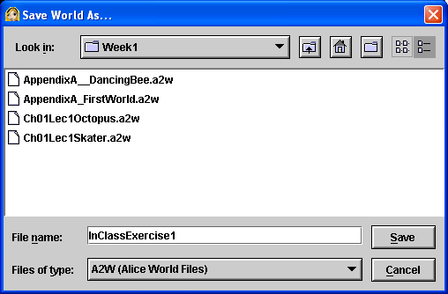

- Type the name InClassExercise1, exactly as you see it above in the File name input box. Notice that the file type shown below the File name input box is A2W (Alice World Files). This indicates that the file you save will end in the extension .a2w, for Alice version 2 World. You should NOT change this. Chick the Save button to save your world.

- Upload your world to your K: drive ToFaculty folder.

